**React Vs Next Js –**

**Fundamental difference –**

**NextJs app is SSR (Server Side rendered app) –**

If you view page source of next js app then you will get full page already rendered (it helps in SEO).

But in react app theres a root div and the content gets rendered there in client side by js.

**Catch all routes in Next Js –**

**To catch all routes in next js create a folder with this syntax – […filePath]**

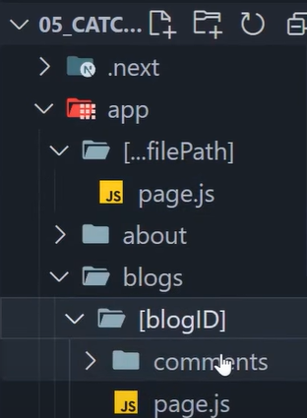

**Then inside it create page.js file and in this page.js file you will get an array of params containing all the params –**

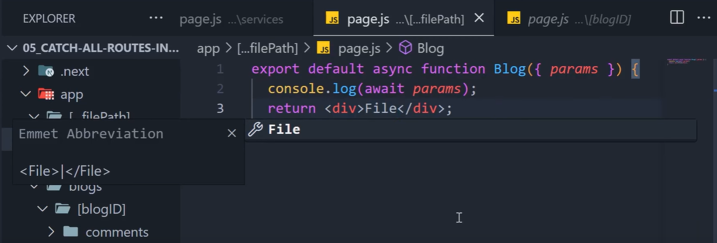

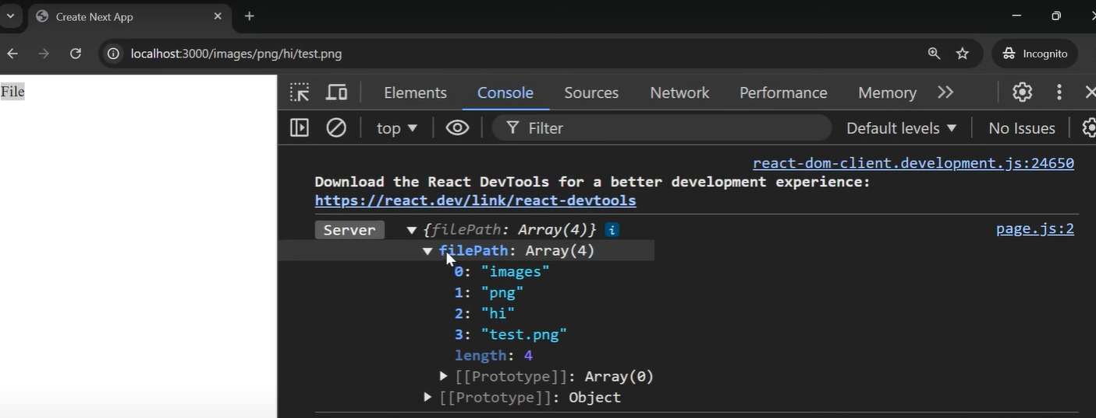

**If you have already made a path then that path will work how you have made it but if you haven’t defined a path then you will get it here.**

**The traditional way to use catch all paths is by using it under a folder called file –**

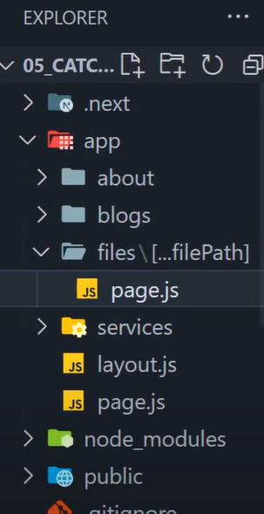

**So it will work only on path starting with file as it is mainly used to serve a file.**

**Optional catch all route –**

**To create a optional catch all route page you can put the […filePath] in one more [] – [[…filePath]] –**

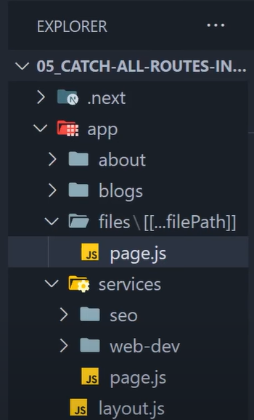

**What this will do is serve the page.js file if the user enters on just /files (cause now …filePath is optional so that means if there is no params after file then the page.js file will be served for files folder.**

**Note – we cannot use optional catch all route on root level because it will conflict with the root folders page.js file.**

**Reusable layouts in Next Js –**

**You can create a layout.jsx file in every route that renders before page.tsx**

**Custom not-found page –**

**To add a custom not found page in next js you need to create a component name not-found.tsx and then you can use is anywhere using notFound() function in next js –**

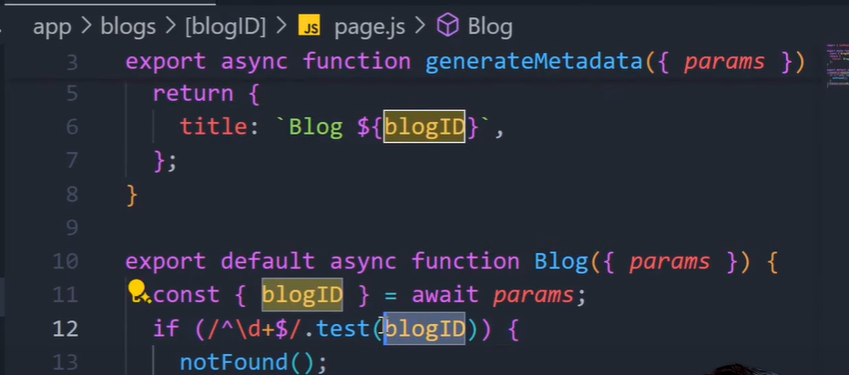

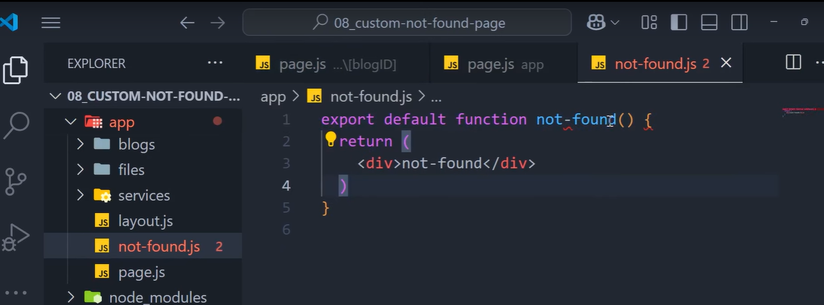

**You can create custom not-found pages for custom routes by making a not-found.tsx file under that folder or route (we do not get params under this not-found page), however you can do it by making the not-found component “use client” and then use a hook called usePathname()**

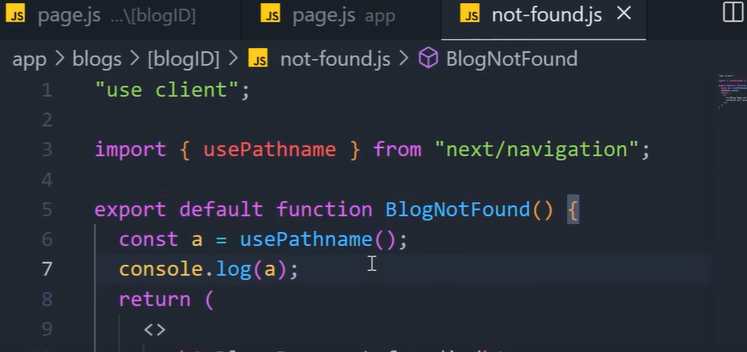

**Routes Group in Next JS –**

**Used to group routes in a single folder without adding that folder to the path**

**It is done by adding the group folders name inside paranthesis () –**

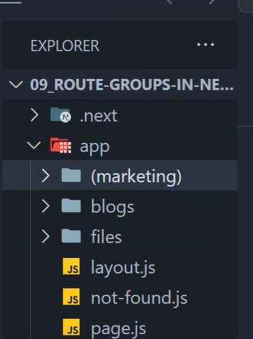

**You can make custom layouts for group routes like this –**

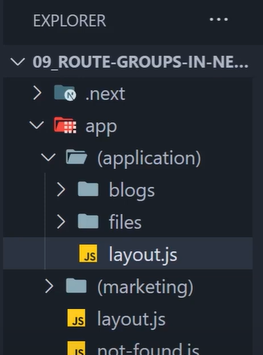

**Private folders in Next JS –**

**If you don’t want to serve a folder by page.tsx file then you can make that folder private by adding a underscore before the folder name -**



**Next JS wont serve this folder as routes**

**However just in case you want to make a route with underscore in beginning you can use %5F –**

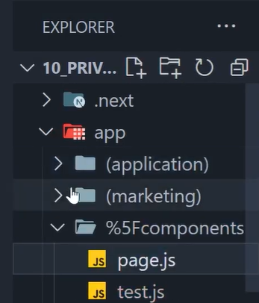

**Now this is a public route with _underscore in beginning**

**Rendering Paradigms in Next JS –**

**Where the html file of our app can be generated?**

1. **Server – back then it was the traditional way**
2. **Client – popularized by client side rendering frameworks like Angular, React, vue, etc. (around 2009-10)**

**Drawback of client side rendering is seo optimization**

**Next JS combines SSR and CSR.**

**SSR consists of Server Site Generation (SSG) and Incremental Site Regeneration (ISR)**